Data lake tables

Lab 1: Create a schema and tables
Estimated completion time
- 20 minutes

Learning objectives
- This lab will show you how to perform basic database operations with Starburst Galaxy using Hive. This includes the creation of schemas and tables, using a number of different methods. The lab also introduces the concept of Inserts, record updates, and external tables.

Prerequisites
- Student setup - Lab 1: Create student account

Activities
- Sign in and verify cluster
- Create a schema
- Create a table using CREATE TABLE AS
- Verify match between data using the EXCEPT command
- Generate Data Definition Language (DDL)
- Connect catalog
- CTAS region table from tpch.sf1.region
- Create friends table
- Verify file format using SHOW CREATE TABLE
- Add a record to the table using INSERT INTO
- Update a record
- Join friends and nation tables
- Using external tables in Hive

Step 1 - Sign in and verify cluster
Sign in and verify the students role is selected in the upper-right corner of the screen.

Navigate to the Clusters list and take any corrective action required to ensure aws-us-east-1-free is reporting a Status of Running before continuing.

Navigate to Query > Query editor and expand aws-us-east-1-free under the cluster list.

Step 2 - Create a schema
In the editor pane, create a new schema with the following command. Make sure that you replace yourname with your actual name, or another identifier that you prefer. Only use lowercase characters and numbers; no special characters or spaces.

CREATE SCHEMA
students.yourname;

Confirm that the schema named students.yourname that you just created is visible. Expand the students catalog. Confirm that your new schema is empty, as pictured in the image below. There will be other schemas listed.

Note: Remember, if you named your schema as yourname, create the schema again with the prerequisite lab’s instructions.

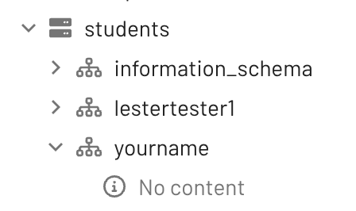

Run the following SQL command to verify your newly created schema is empty. This provides secondary confirmation that there is nothing in it.

SHOW TABLES
FROM
students.yourname;

Step 3 - Create a table using CREATE TABLE AS
Next, it’s time to create a new table within your student schema following the format and contents of the tpch.sf1.nation table.

To do this, start by running a query against the tpch.sf1.nation table to verify there are 25 rows present. This helps us to ensure that we understand what information is held in the table before we recreate the same information in the student schema.

USE students.yourname;
SELECT
*
FROM
tpch.sf1.nation;

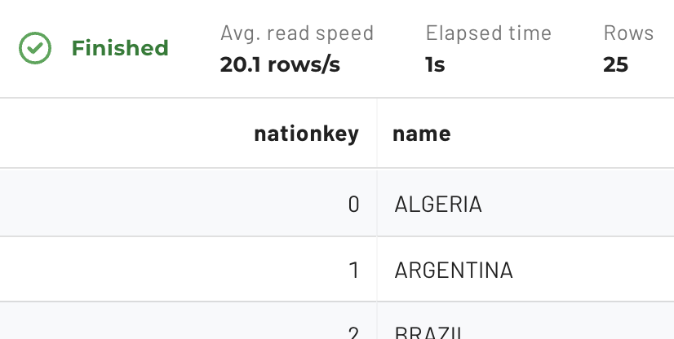

Next, review the CREATE TABLE AS (CTAS) documentation then create a table named nation in your schema that has the same format and content as tpch.sf1.nation.

CREATE TABLE
nation AS
SELECT
*
FROM
tpch.sf1.nation;

Verify in the schema hierarchy that your new table exists and has the correct structure and content. Now use the DESCRIBE command to achieve the same output using SQL.

DESCRIBE nation;

Step 4 - Verify match between data using the EXCEPT command
After running SELECT queries on the original table and your nation table, run the EXCEPT query listed below. It will verify that the two tables contain the same data.

SELECT * FROM nation
EXCEPT
SELECT * FROM tpch.sf1.nation;

Step 5 - Generate Data Definition Language (DDL)
When you create a table, you need to define the data structure that will be employed. This is known as the Data Definition Language (DDL). Starburst helps you automate this process.

In the left-hand navigation bar, click the vertical ellipses menu under the students.yourname.nation table to generate the Data Definition Language (DDL) for that table.

Select the SHOW CREATE TABLE option shown in the image below.

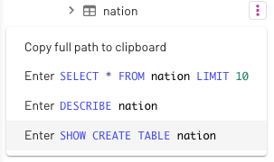

The system generates the following output which has two focus areas.

Output

CREATE TABLE students.yourname.nation (
nationkey bigint,
name varchar(25),
regionkey bigint,
comment varchar(152)
)
WITH (
format = 'ORC',
type = 'HIVE'
)

The first focus area, noted blue, defines the logical representation of the table. It provides information about the schema which will be applied to the table and is similar to the approach used to construct a table in other database systems.

The second focus area, noted in red, defines two other crucial aspects of schema-on-read solutions, specifically:
- The file format being used, in this case, ORC.
- The table format used, in this case, Hive.

Step 6 - Locate the data
Notice that you did not define a specific folder location in the CREATE TABLE statement in the last step. Although a specific location can be defined if needed, it can also be left undefined. When left to the default, it is based on where the schema itself is rooted in the data lake hierarchy.

Note: You do not have access to view the configuration of catalogs in the UI, nor to view S3 via the AWS management console. Screenshots are presented to aid in your understanding of where the data for the nation table is located.

When the instructor created the students catalog, the following elements were visible.

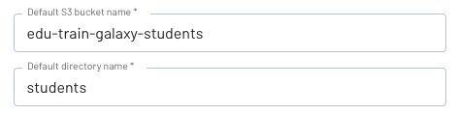

By default, the schema is stored in a folder name below the Default directory name. Notice students directory name and the bucket named edu-train-galaxy-students. The table name is then another folder directly below the schema’s folder.

This means your table’s base directory is students/yourname/nation. If you had access to AWS S3, you would see this directory tree.

The folder contains data files. In this case, you only have a single file because the table only has 25 rows.

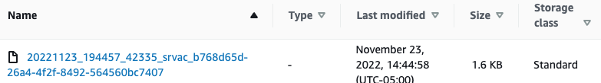

As you can see below, the contents of this ORC file are not in a humanly readable format and cannot be read using a text editor.

Note: The ORC tools jar is a straightforward way to visualize the data within. File format options will be discussed further in the next lesson.

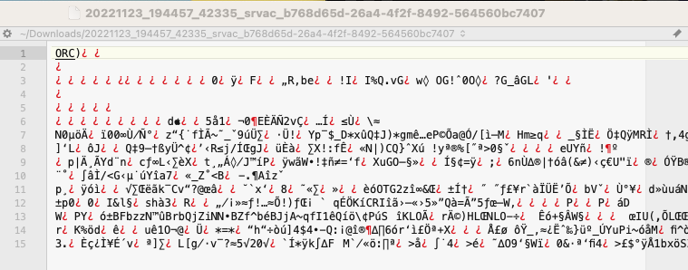

Step 7 - CTAS region table from tpch.sf1.region
Now it’s time to use a similar process to copy the data from the tpch.sf1.region table into a new region table in your schema. Write another CTAS command using the code below.

CREATE TABLE
region AS
SELECT
*
FROM
tpch.sf1.region;

Now join the two tables to determine the number of nations in each region.

SELECT r.name, COUNT() AS nbr_nations
FROM nation n
JOIN region r ON (n.regionkey = r.regionkey)
GROUP BY r.name
ORDER BY nbr_nations DESC;

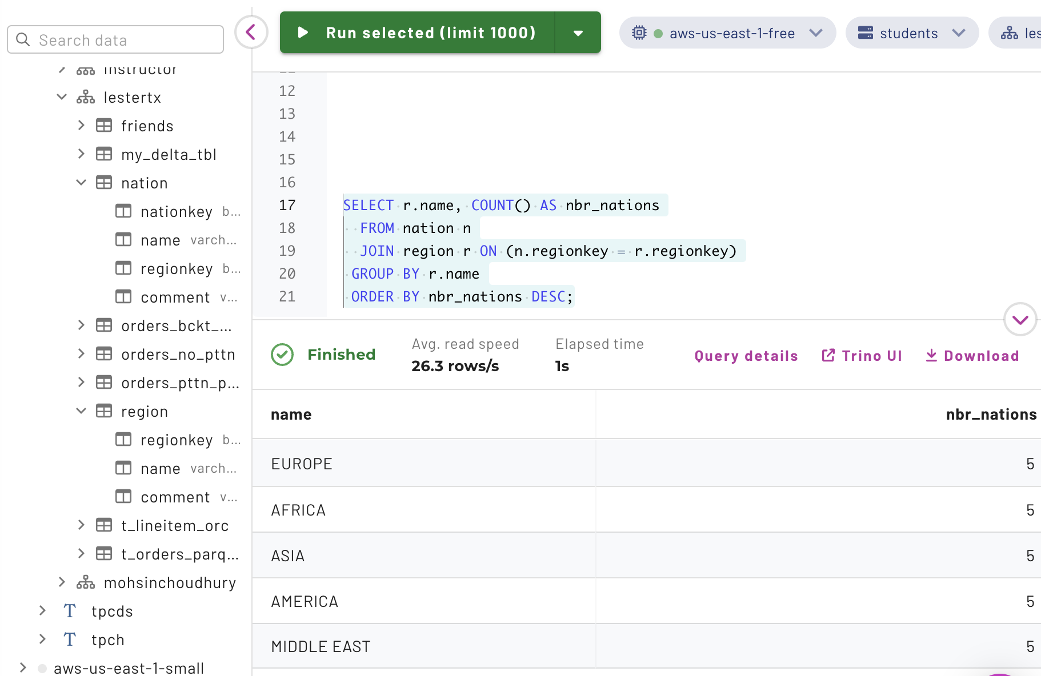

Step 8 - Create friends table
Next, it’s time to create a new table that will contain information about your friends. Use the code below.

CREATE TABLE friends (
name varchar(100),
year_met smallint,
fav_color varchar(50),
nation_born bigint
);

Notice that you did not define the WITH section. The location of the file system will default to something similar to //filesystem/catalog/schema/table. The folder will not be created until the table is populated with data.

Step 9 - Verify file format using SHOW CREATE TABLE
If the file format is not identified, the table will use the catalog’s default file format. Verify that the file format is ORC by running a SHOW CREATE TABLE statement.

SHOW CREATE TABLE friends;

Your output should look like the following.

Output

CREATE TABLE students.yourname.friends (
name varchar(100),
year_met smallint,
fav_color varchar(50),
nation_born bigint
)
WITH (
format = 'ORC',
type = 'HIVE'
)

As for the type property above, you will learn more about “table formats” in an upcoming lesson.

Step 10 - Add a record to the table using INSERT INTO
Now that the table is created, you can add records individually to it using the INSERT INTO command.

Add a record to this table using the following data.

INSERT INTO
friends (name, year_met, fav_color, nation_born)
VALUES
('Fred', 2002, 'brown', 13);

When you add a record, it’s considered best practice to check that the record has been successfully added. To do this, run a query to make sure the record was added to the table as intended. You should have all of the information you need to run this, but if you get stuck, review the previous steps or ask the instructor for help.

As before, you do not have access to view the S3 UI directly. These screenshots will help you understand what is present. The S3 object store now contains a folder for this table and a single file for this record. It should look similar to the image below.

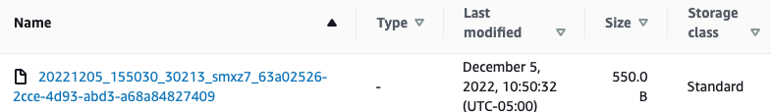

Now that you’ve added one record, try adding three records in the same INSERT INTO command.

INSERT INTO
friends (name, year_met, fav_color, nation_born)
VALUES
('Susie', 2012, 'blue', 9),
('Bertha', 1999, 'pink', 24),
('Franklin', 2019, 'green', 24);

Verify the records have been added by running a query. There should now be four rows in the table.

SELECT * FROM friends;

If you could see the table’s S3 folder you would notice there are two files now similar to the following example.

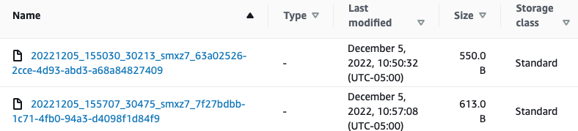

One of the files was created with the original INSERT statement and the other from the second INSERT. The three recently inserted records are all located in the second file. In the next lab, you will explore these files in more detail using the Hive special columns feature.

Run the original INSERT statement again.

INSERT INTO
friends (name, year_met, fav_color, nation_born)
VALUES
('Fred', 2002, 'brown', 13);

Do you see the same record twice?

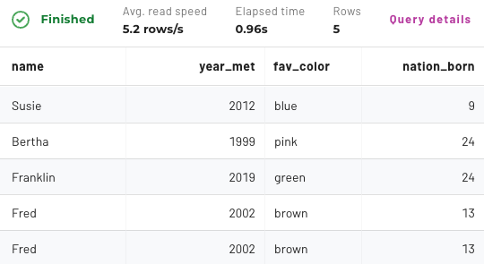

The image above shows that one of your records has been duplicated. This happened because you did not declare a primary key (PK). It highlights a key point: when working with big data schema-on-read tables such as this, you will not have the chance to create (or validate) a primary key. Instead, data integrity activities like this are managed by the process that populates the table. This will be covered in greater detail in the data pipelines lesson.

Step 11 - Update a record
Often, it is necessary to update a record. Try to update one of the records you already created using the code below.

UPDATE friends
SET fav_color = 'purple'
WHERE name = 'Susie';

This raised the following error message.

The error message identifies the problem. Do you think there will be a problem with trying a DELETE on this same row? Try it and see.

DELETE FROM friends
WHERE name = 'Susie';

This next error message reads as follows.

You will address partitions in a future module, but Hive tables are generally insert-only in nature. As mentioned previously, alternate “table formats” which allow full INSERT, UPDATE, and DELETE features, as well as usage of the MERGE command, are covered in a future lesson.

Additional efforts must be employed with Hive tables to recreate the underlying files from which the table gets queried.

Step 12 - Join friends and nation tables
Join the friends table with the nation table you created earlier to determine how many of your friends were born in each nation.

SELECT n.name, COUNT() AS nbr_friends
FROM friends f
JOIN nation n ON (f.nation_born = n.nationkey)
GROUP BY n.name
ORDER BY nbr_friends DESC;

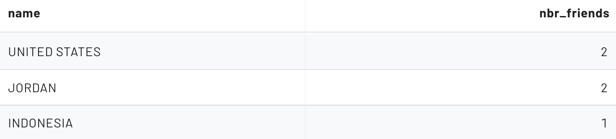

Adjust your query to join your friends on another schema’s (from the students catalog) nation table, such as students.ANOTHERNAME.nation.

Note: If you cannot find a nation table from anyone else’s schema, you can always use the tcph.tiny schema.

With traditional RDBMS software, you can enforce the relationship between these two tables with a foreign key (FK). As with PK constraints, Hive tables do not offer this type of integrity check. This allows you to add a record with a value that is not in the nation table, as illustrated in the following statement.

INSERT INTO
friends (name, year_met, fav_color, nation_born)
VALUES
('John', 2021, 'khaki', 999);

Verify that this is the only record that does not have a matching nation table entry.

SELECT *
FROM friends
WHERE nation_born NOT IN (
SELECT nationkey FROM nation
);

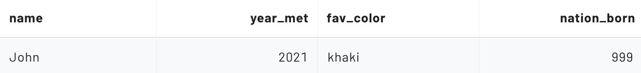

Similar to the PK, the burden of ensuring a logical FK constraint is not introduced into the data to be queried is the responsibility of the data pipeline process.

Eliminate the friends table now that you are finished with it.

DROP TABLE friends;

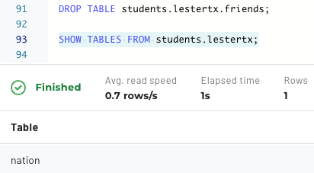

Step 13 - Using external tables in Hive
Up to this point, you have been creating Hive tables that are sometimes called managed tables. Generally speaking, you let the system identify where the underlying location will be, as the earlier example explained. While each table is configured to a specific directory and has a known file type, you do not typically place files on the filesystem directly. The Trino engine does the heavy lifting for us as a result of a command such as INSERT.

Additionally, when a DROP TABLE command is issued on a managed table, the underlying data is deleted along with the table’s metadata.

External tables are the other primary type of Hive tables. External tables are often located in an alternate data lake location than where Trino would typically store them. You can identify these tables by the presence of the external_location property in the DDL. Review and execute the query below.

CREATE TABLE
external_logs (
event_time TIMESTAMP,
ip_address VARCHAR (15),
app_name VARCHAR (25),
process_id SMALLINT,
log_type VARCHAR (15),
log_level VARCHAR (15),
message_id VARCHAR (15),
message_details VARCHAR (555)
)
WITH
(
external_location = 's3://edu-train-galaxy/serverlogs/logs_5min_ingest_csv/',
format = 'TEXTFILE',
textfile_field_separator = ','
);

Verify the results from a SELECT statement against this new table look appropriate.

SELECT * FROM external_logs;

External tables are often utilized when another system is creating the files. For example, a frequent scenario is an external table being used for recently ingested files that are being loaded into the data lake. In addition to allowing other systems to populate data into the table, these data lake files are easily consumable from other frameworks and systems.

In the ingestion model, you often see similar-sized files placed in the table’s underlying directory periodically. Starburst does not care what these files are named, but depending on the system saving the files, you may get some heuristic information from the file names. You might be able to decipher the pattern from these example files being used in the table you just created.

Remember, you do not have access to S3 directly and these screenshots are presented to aid in your understanding.

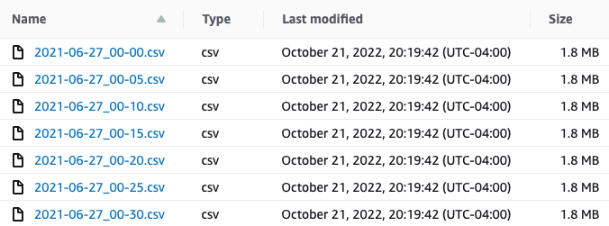

Note: you will see these files again in the next lab as the basis of some of your performance enhancement techniques.

Another huge difference with external tables is related to when the table is dropped. Only the metadata is removed. The actual data is left alone. To validate this, drop the external_logs table you just created. Recreate it and confirm the data is still available.

END OF LAB EXERCISE

